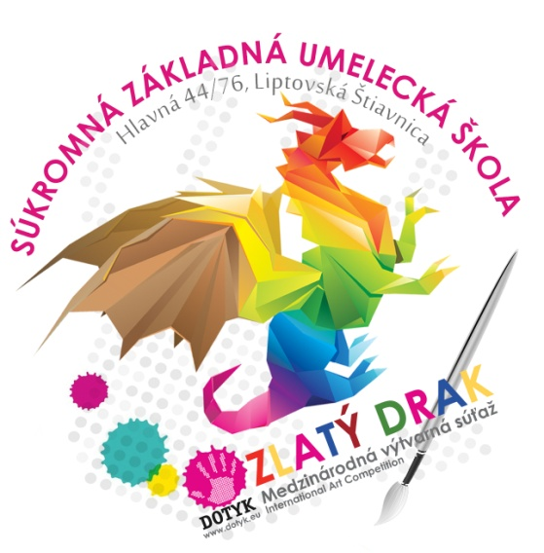
PROPOSITIONS:
Third year of international children´s art exhibition
ZLATÝ DRAK 2017 (GOLDEN DRAGON 2017)

The theme: JULES VERNE - World of adventures
- cesty do hlbín oceánov, vesmíru, okolo sveta ...
- mad scientist, crazy inventions, fantastic machines
- exploring of mysteries and mysterious world
- choose a favorite Verne´s story and design a book cover
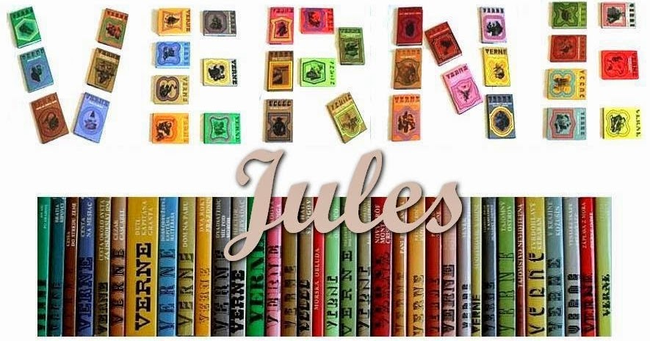
Organizers /work delivered to the address /:
Súkromná základná umelecká škola Dotyk, Hlavná 44/76, 03401 Liptovská Štiavnica

Deadline for sending works: 31/03/2017
Evaluation / the awards ceremony: April 2016, Liptovské múzeum Ružomberok (Liptov Museum)
Conditions for participation
- Zlatý drak 2017 (Golden Dragon 2017) is one round competition for children from 3 to 15 years
- The maximum format of a 2D work is 100x70cm
- The maximum format of a 3D work is 100x100cm
- It is possible to send more artworks by one author, but different art techniques
- Original copies are acceptable only. Copies, Xerox copies or electronic copies will not be eligible for assessment
- Artwork should be fixed / dry pastel /, properly labeled
- Use the WORK IDENTIFICATION LABEL (The label must be written electronically) to label competing artworks please
- Artworks that fulfills the theme and the conditions set by organiser will be eligible for assessment only. Works lacking proper label will be excluded.
- Artwork can´t be older than one year and may not be published or awarded previously
- Send also the inventory list of all sent artworks which is part of the propositions / just write by hand and attached to the work or by e-mail - paskova@dotyk.eu/
- Works submitted to the competition will not be returned

Awards
- Jury Award
- Headmaster of Art school “Dotyk” Award
- Founder of Art school “Dotyk” Award
- Liptov Museum Ružomberok Award
- Medal for the collection of works for school
- Collective work of children Award
- Honorable Mentions / diplomas

Art techniques:

- 2D art techniques : drawing / painting, graphics, combined techniques, photography/film
- 3D art techniques: ceramics, metal, textiles, paper, glass, wood

The label on the designation of work:

ZLATÝ DRAK 2017
3rd year of international children´s art exhibition
Name and surname of the child
Age and sex of the child (marked with a cross) | Male |  | Female |  | Age
Title of artwork |  |  |  | Technique used
Name and full address of the school
Contact
Name of the teacher

Inventory list of all sent artworks "ZLATÝ DRAK 2017"
Address of the school
Order | Name of the child/ age | Title of artwork | Technique used | Teacher

